Session 7

1.Create a table called Orders with columns: order_id, user_name, total_amount, and order_date. Insert 5 sample rows with different users and order amounts, including at least one NULL value for total_amount.

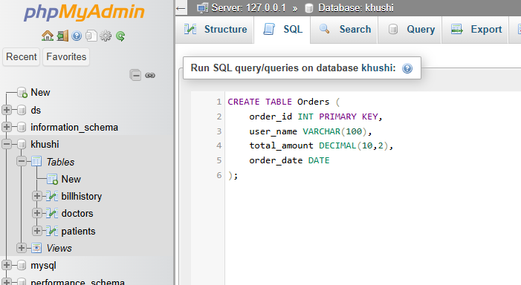

2.Write a SQL query to count how many orders were placed by each user in the Orders table, displaying user_name and the number of orders as order_count.

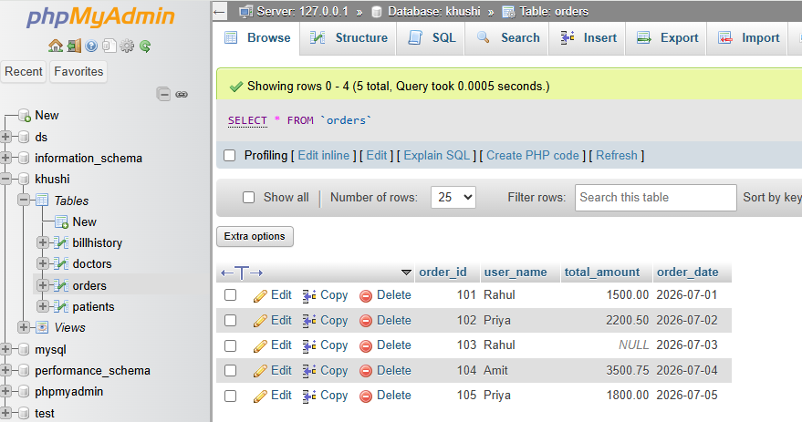

3.Write a SQL query to calculate the average total_amount of all orders in the Orders table, making sure to ignore any NULL values.

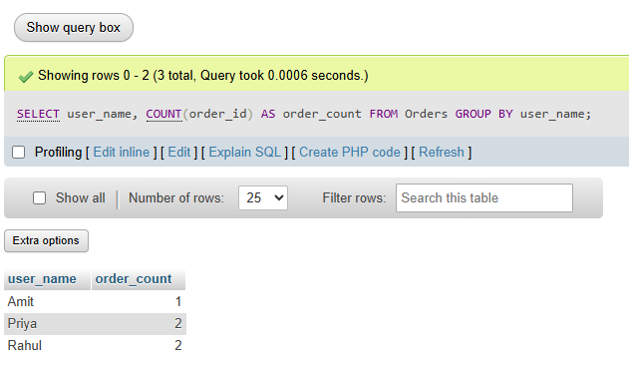

4. Suppose you are building a Flipkart-style dashboard: Write a SQL query to find the highest and lowest order amounts (MAX and MIN) from the Orders table, and display both values in a single result row.

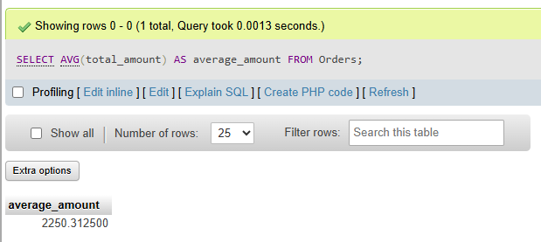

5. Write a SQL query to calculate the total sales (SUM of total_amount) for all orders, but only include orders where total_amount is not NULL.<br><br><em><strong>Hint:</strong> Use a WHERE clause to filter out NULL values before applying the SUM function.</em>.
